Tech Nation Visa — Global Talent (Exceptional Promise)
Criteria: Optional Criteria 4 — Academic Contributions through Research
Applicant: Odeyemi Olusegun Israel
OC4-2: Publications & Research Dissemination
1. Executive Summary
I wrote and published four research paper independently , without university affiliation, co-authors, research funding, or any promotion budget. They are hosted on TechRxiv (IEEE) and Zenodo (CERN), both with permanent DOIs and open public access. The papers have accumulated 365 views and 210 downloads organically, with no advertising or outreach. This section documents the publication record as evidence of independent research dissemination.
2. The AMTTP Infrastructure Paper (TechRxiv)
Introduces the AMTTP platform — a four-layer compliance enforcement framework for institutional DeFi. Published on TechRxiv with a permanent DOI. This is the foundational infrastructure paper documenting the platform described elsewhere in this application.
Field | Detail
Published | 27 February 2026
Metrics | 230 Views, 153 Downloads (as of 5 May 2026)
Platform | TechRxiv — IEEE engineering preprint server
DOI | 10.36227/techrxiv.177220113.33816607/v1
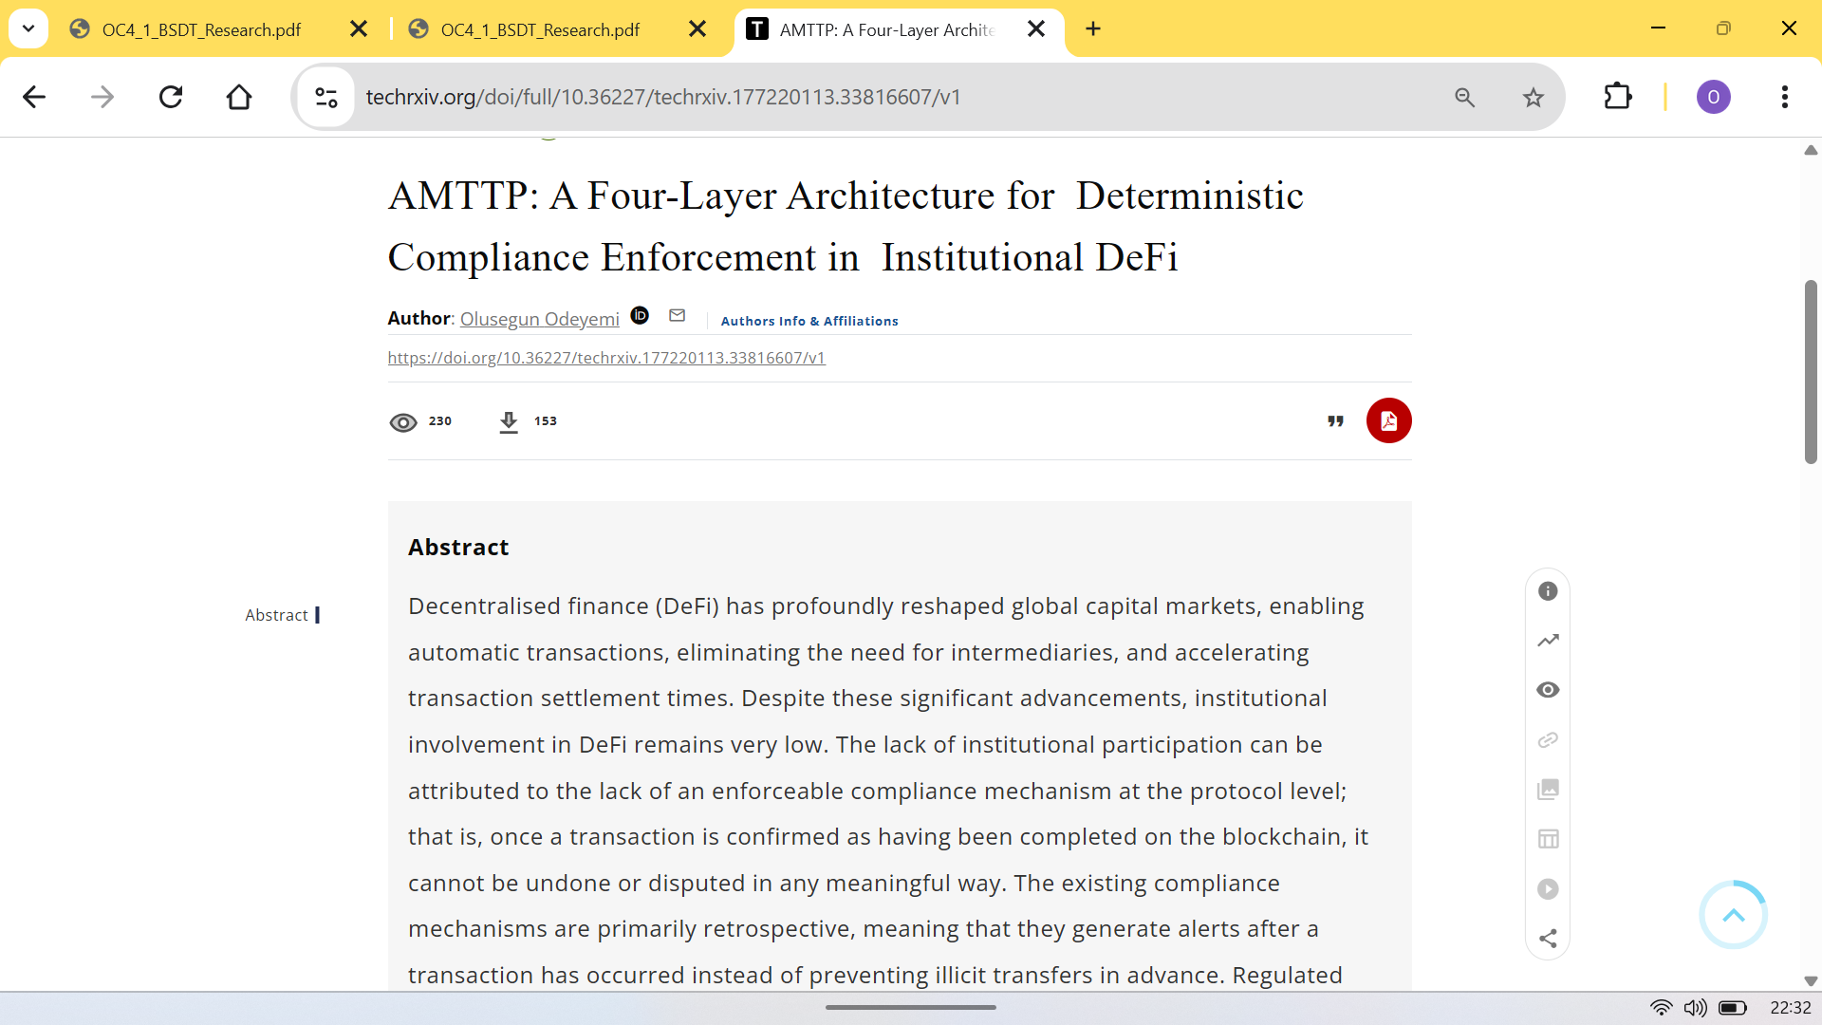
Figure 1: Platform analytics for the AMTTP paper on TechRxiv — 230 views and 153 downloads as of 5 May 2026. No institutional or co-author network was involved; all readership is organic.
3. Blind-Spot Decomposition Theory — BSDT (Zenodo)
Introduces Blind-Spot Decomposition Theory — a mathematical framework that decomposes fraud-detection failures into four independent channels (camouflage, information gap, unseen pattern, outdated baseline). Detailed in OC4-1. Published on Zenodo with a permanent DOI.
Field | Detail
Published | 5 March 2026
Metrics | 135 Views, 57 Downloads (as of 5 May 2026)
Platform | Zenodo — CERN-hosted open-access archive
DOI | 10.5281/zenodo.18870590
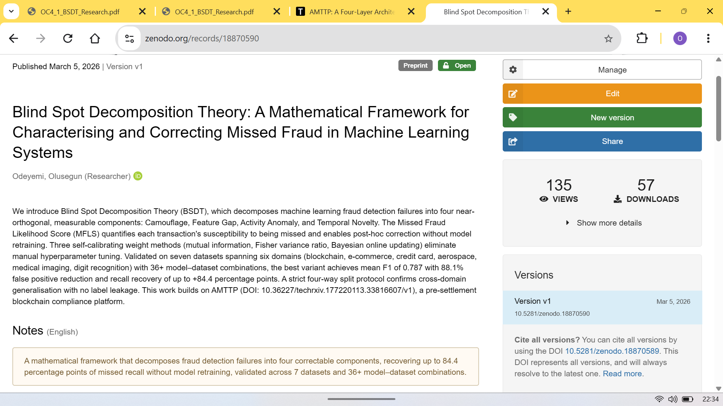
Figure 2: Platform analytics for the BSDT paper on Zenodo — 135 views and 57 downloads as of 5 May 2026.
4. Blind-Spot Decomposition and the Geometry of System Collapse (Zenodo)
Extends the BSDT decomposition framework to cross-domain instability detection, applying the same mathematical channels to publicly available power-grid and cryptocurrency crisis datasets. Presented as an exploratory extension of fraud-detection principles to structurally analogous time-series problems. Published on Zenodo with a permanent DOI.
Field | Detail
Published | 16 March 2026
Platform | Zenodo — CERN-hosted open-access archive
DOI | 10.5281/zenodo.19038783
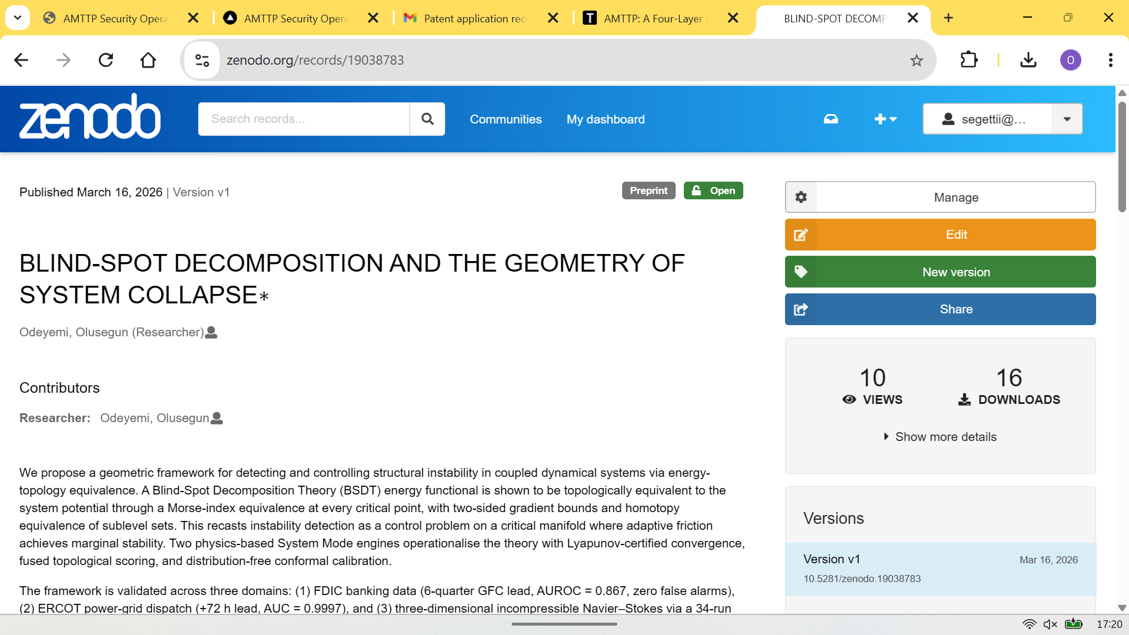
Figure 3: Zenodo record for ‘Geometry of System Collapse’. DOI: 10.5281/zenodo.19038783.
5. Universal Deviation Principle (Zenodo)
Introduces a broader detection framework that monitors multiple types of unusual behaviour simultaneously, with mathematical guarantees on detection sensitivity. Extends the deviation-based approach from BSDT to more general classification settings. Published on Zenodo with a permanent DOI.
Field | Detail
Published | March 2026
Platform | Zenodo — CERN-hosted open-access archive
DOI | 10.5281/zenodo.19037688
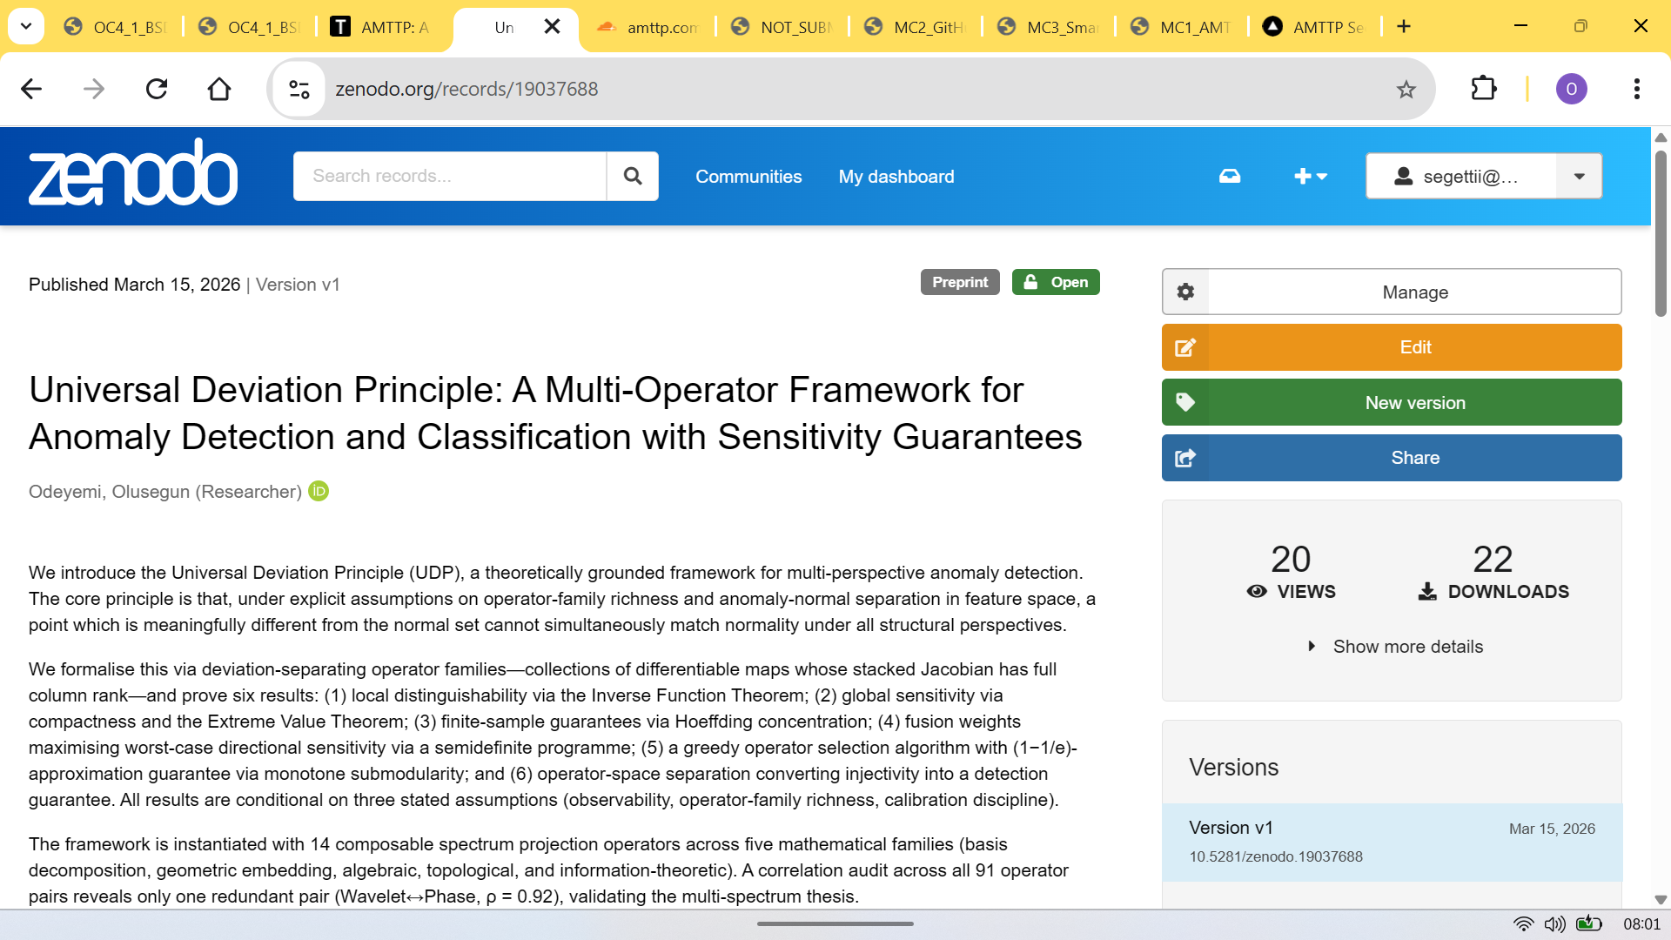
Figure 4: Zenodo record for ‘Universal Deviation Principle’. DOI: 10.5281/zenodo.19037688. Published March 2026.
6. Public Reach & Traceability
All four papers are freely accessible via permanent DOIs. The view and download figures reflect organic readership — no promotion, outreach campaign, university network, or co-author was involved. Three papers were later incorporated into postgraduate course materials by Dr Sunday Adeola Ajagbe (see accompanying signed reference letter and the embedded course slide below).
Paper | Platform | Views | Downloads | Adopted (CPE 604)
AMTTP Infrastructure | TechRxiv | 230 | 153 | Yes
BSDT Framework | Zenodo | 135 | 57 | Yes
Geometry of System Collapse | Zenodo | — | — | Yes
Universal Deviation Principle | Zenodo | — | — | No
Total | — | 365 | 210 | 3 of 4
Table 1: Publication summary showing platforms, DOIs, and public metrics. Counts are independently verifiable at the DOI URLs listed above.
The view and download counts are independently verifiable at the DOI pages listed above. Both platforms display their analytics publicly.
Scope of this claim: these are open preprint and archive publications rather than journal-accepted papers. The evidential value lies in independent dissemination, public discoverability, and organic readership without institutional support — not in journal impact metrics.
7. Independent Academic Adoption
Three of the four papers above were later incorporated into postgraduate course materials at Abiola Ajimobi Technical University, Nigeria, by Dr Sunday Adeola Ajagbe. The selection was independent — no submission, no prior relationship. The lecture slide below shows the applicant's papers listed under 'Recommended Readings' alongside established peer-reviewed work. A signed reference letter from Dr Ajagbe is provided as a separate supporting document.
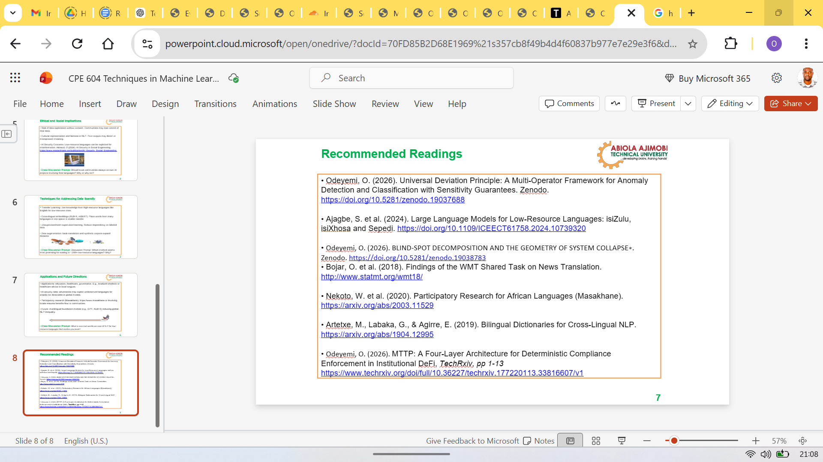
Figure 5: Lecture slide from CPE 604 (Techniques in Machine Learning for Low-Resource Languages) showing three of the applicant's papers in the course's Recommended Reading list.

